Python Programming Lab Task Sets

Set 1
- Q1. Write a Python function to calculate the factorial of a number. Use a coding assistant and document how you refine your prompt to ensure the function handles negative input and zeros.
(Each question carries 5 marks)
- Q2. Given a list of student marks, compute the mean and list all students above the mean. Demonstrate zero-shot, one-shot, and few-shot prompts to guide an AI tool to solve this. Summarize the differences in approach.
(Each question carries 5 marks)

Set 2
- Q1. Write a Python function `is_prime(n)` to check if a number is prime. Use an AI coding tool to generate and justify a set of test cases before implementation. Pass all generated test cases.
(Each question carries 5 marks)
- Q2. Develop a Python class `Rectangle` with methods for area and perimeter. Use an AI assistant for auto-generating docstrings and inline comments. Compare them with your manual documentation.
(Each question carries 5 marks)

Set 3
- Q1. Implement a Python class for a stack data structure (`push`, `pop`, `peek`). Use GitHub Copilot to generate code, test its handling of edge cases, and explain any improvements made.
(Each question carries 5 marks)
- Q2. Refactor a poorly commented Python function using an AI assistant for automatic documentation. Evaluate clarity and completeness versus manual comments.
(Each question carries 5 marks)

Set 4
- Q1. Create a function to reverse a list in Python. Use an AI tool to suggest alternative implementations. Test and compare the performance of each version.
(Each question carries 5 marks)
- Q2. Design a few-shot prompt to guide an AI tool in writing code for a basic linked list with methods for insert and delete. Analyze the resulting code for correctness and completeness.
(Each question carries 5 marks)

Set 5
- Q1. Generate Python code for the Fibonacci sequence with Cursor AI. Refine your prompts to handle only positive integers and record the changes and outcomes.
Prompt
Generate Python code that prints the Fibonacci sequence. Make sure it only works for positive integers. If the user enters anything else, show an error message. After generating the code, also explain what changes were made and what the results were.
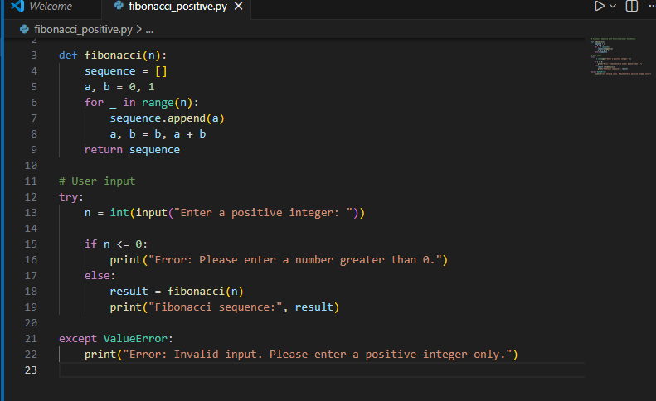 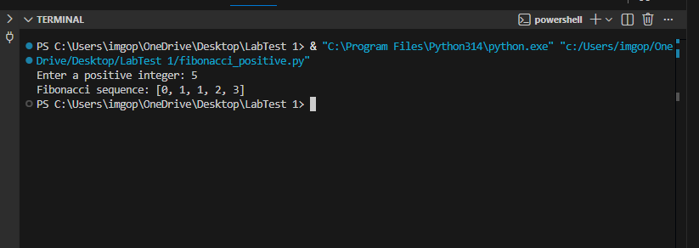
(Each question carries 5 marks)
- Q2. Write a Python queue class (`enqueue`, `dequeue`, `peek`). Use an AI assistant and test the class with multiple scenarios. Describe how AI-generated code manages edge cases and how you improved it.
Prompt
Write a Python Queue class with enqueue, dequeue, and peek functions.
Make sure it handles cases like when the queue is empty.
Then test it with many examples:
– adding items
– removing items
– checking the first item
– trying to remove or check when the queue is empty
* Also explain how the AI code handled errors and what changes or improvements I made after testing.
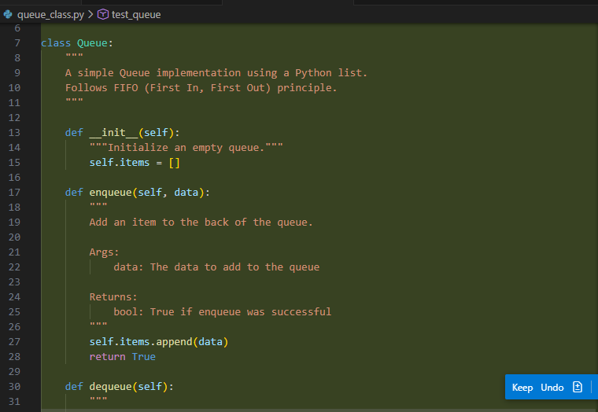
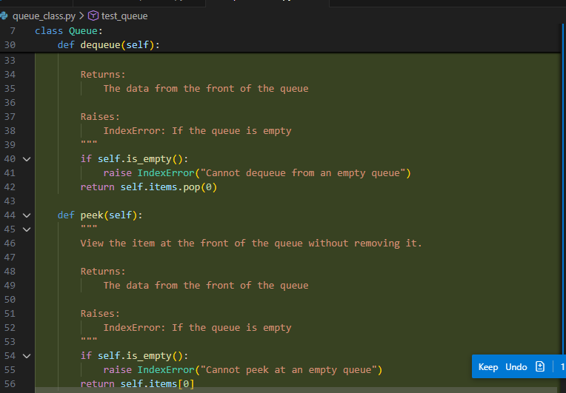
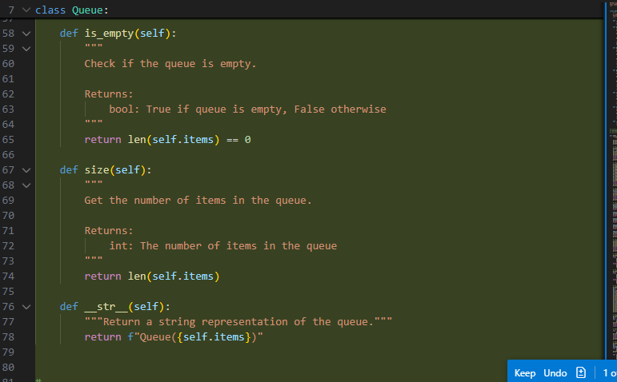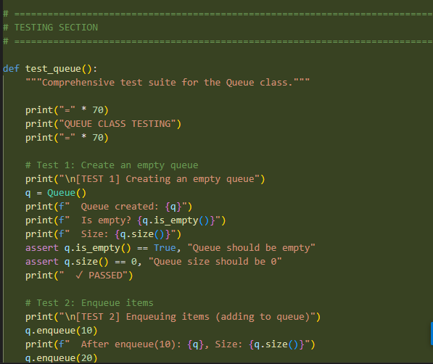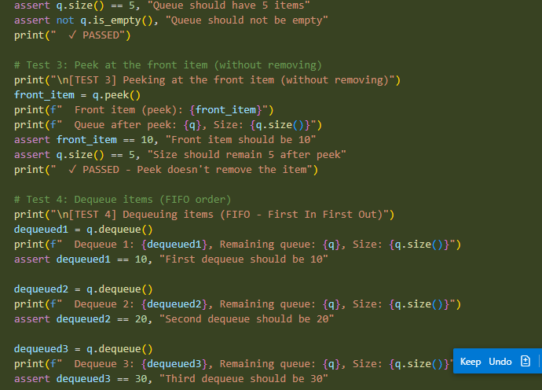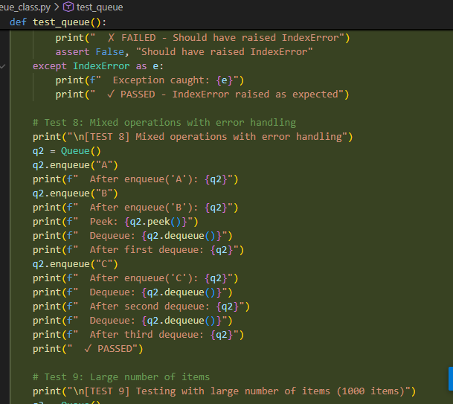
Output
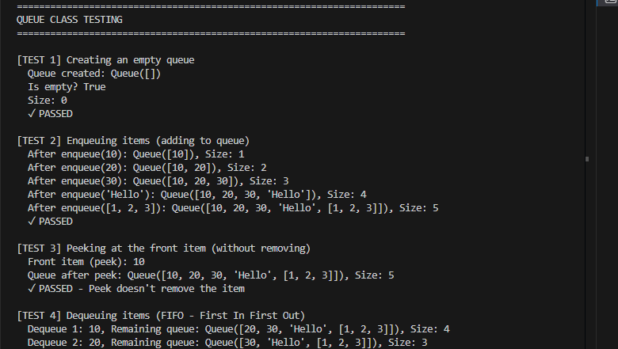

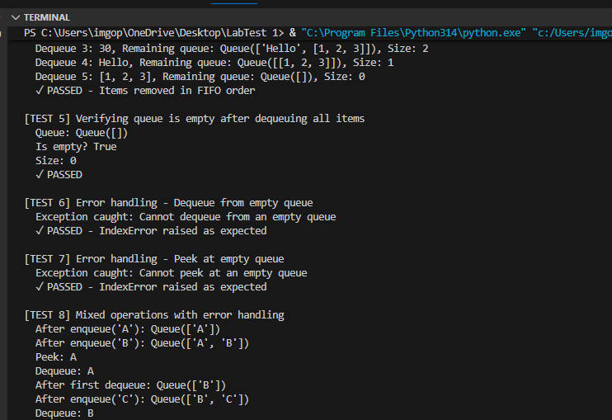
(Each question carries 5 marks)

